The Murray-Darling River system — Stimulus sheet
Source 1: Map of the Murray-Darling Basin Source 2: Characteristics of the Murray-Darling catchment

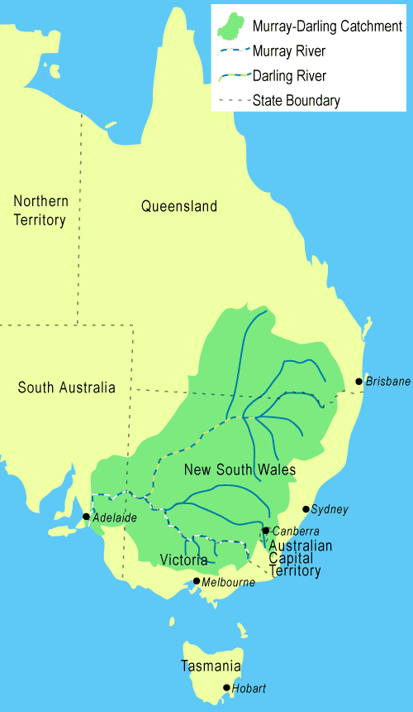
Martyman, Murray catchment map, http://commons.wikimedia.org/wiki/File:Murray-catchment-map_MJC02.png CC BY-SA 3.0 creativecommons.org/licenses/by-sa/3.0/deed.en

Source 3: Salinity  The cost of salinity in the Murray Darling Basin is estimated to be more than $300 million a year. Without intervention, predictions are that as much as 50 per cent of New South Wales alone would be threatened by excessive salinity in the next two decades. Many farmers would lose their livelihoods and communities along the Murray-Darling may well disappear.  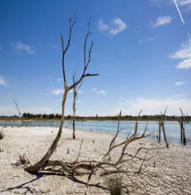  Image: Mark Mohell & DSEWPaC http://www.environment.gov.au/cgi-bin/media/imagedb/imagesearch.pl?proc=detail;termids=271;start_rownum=168;last_rownum=168;no_rows=770;mode=full Reference: Office of Environment and Heritage http://www.environment.nsw.gov.au/salinity/ | Source 4: Algae blooms  Runoff and erosion from fertilised agricultural areas, and sewage effluent are the major sources of phosphorus and nitrogen (nutrients) entering water ways, contributing to the growth of algal blooms.  Managing algae blooms is extremely costly. For example, New South Wales spends as much as $240 million a year on clean-up measures. The first major algae bloom in the Murray-Darling Basin in 1991 affected 1000 kilometres of the river. People’s lives are affected, as water for household use becomes unavailable until the bloom has been cleaned up.  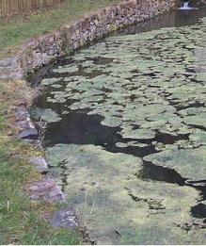  Reference: http://www.water.nsw.gov.au/Water-management/Water-quality/Algal-information/Algal-management-in-the-southern-basin-of-NSW/Algal-management-in-the-southern-basin-of-NSW  Image: Modified from: Juandev, Rybník Koda, s pramenem http://commons.wikimedia.org/wiki/File:Rybn%C3%ADk_Koda,_s_pramenem.jpg CC BY-SA 3.0 creativecommons.org/licenses/by-sa/3.0/deed.en
Source 5: Levels of inflows into the Murray-Darling Basin  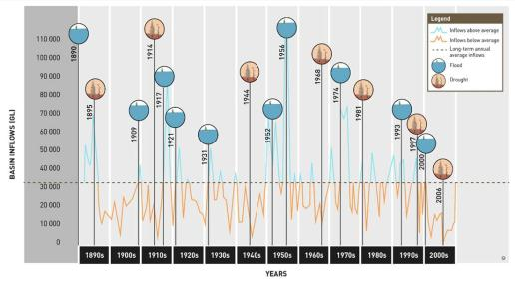 |  |  | Source 6: Murray-Darling Basin Plan  In 2009–2010 a joint agreement was signed between the Commonwealth Government and the governments of the relevant states to ensure the critical needs of each state were met in any proposal for the future of the Murray-Darling Basin. The Commonwealth Government’s $12.9 billion ten-year Water for the future plan made a variety of proposals for the rivers. These included a water buy-back plan where water entitlements would be bought back from willing participants, and that water would be returned to the river system to help stabilise wetlands in particular. The amount of water to be retained and returned to the river is 2750 gigalitres. The plan also includes proposals to help farmers adapt to changing weather patterns and contribute to improving the health of the system.  Reference: Murray-Darling Basin Authority www.mdba.gov.au/
Source 7: Water use by agricultural practices  Data sourced from: Australian Water Resources 2005 http://www.water.gov.au/KeyMessages/WaterUse200405/index.aspx?Menu=Level1_1_7 © DETE  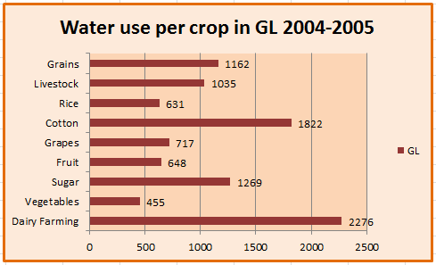  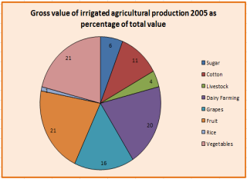 |  |  | Source 8: Reactions to the Murray-Darling Basin Plan  Reactions to the MDB Plan have been varied. Groups such as the Victorian Farmers Federation and the Wine Grape Growers Australia have painted a bleak picture and suggested that whole communities along the river will disappear as their livelihood will be severely compromised by the plan’s proposals to reduce water withdrawals. Irrigators in South Australia, however, feel politics is getting in the way of science and that the original figures for water retention should be maintained. Environmentalists argue 2750 gigalitres will not be enough to restore the environmental balance and ensure the health of the river system. Some have suggested that more water needs to be taken out and other measures, like desalination plants, should be introduced.  © DETE
Source 9: Agroforestry  Agroforestry is the practice of using commercial tree production in low rainfall areas. In Australia, native trees, such as tea trees and melaleuca, can help to maintain the quality of the soil and thus reduce salinity. Such enterprises, however, need to make the most use of the trees. Single product use is not commercially sustainable on a large scale so finding multiple uses is essential. The biomass from such trees can be used for ethanol production, but extraction methods at the moment are more expensive than traditional fuel production methods. This means that biomass use alone will not be sufficient but multi-use strategies would certainly make agroforestry a possible contributor to helping with the Murray-Darling Basin problems.  Reference: Stirzaker, R., Lefroy, T., Keating, B. & Williams, J. 2000, A revolution in land use: Emerging land use systems for managing dryland salinity, CSIRO http://www.clw.CSIRO.au/publications/70445.pdf |  | Stimulus 10: New plants  Crops designed to use available water effectively rather than crops chosen for their economic yield alone should be introduced to suitable areas. Developing existing plants to improve their root capacity and using new plants that have more extensive root systems would help limit the need for irrigation and would attack the problem of salinity. Plants that can last much longer and redevelop of their own accord after an initial harvest would also improve land and water use. Farmers would be less under the influence of the destructive drought/flood cycles, which often bring despair to them as they watch their land drying up or covered in flood waters, and they see their stock dying. Research is already being undertaken to assist in these developments but such plants would probably require at least five years research and development and perhaps even 25 years of such research.  Reference: Stirzaker, R., Lefroy, T., Keating, B. & Williams, J. 2000, A revolution in land use: Emerging land use systems for managing dryland salinity, CSIRO http://www.clw.CSIRO.au/publications/70445.pdf
Source 11: CSIRO Report on Murray-Darling Basin
‘To realise this vision, we will need to pioneer the development of a new landscape, a mosaic of tree crops driven by large-scale industrial markets such as biomass fuels and high-value annual crops, as well as mixed perennial-annual cropping systems, and areas devoted to maintaining those elements of native biota dependent on native vegetation… While a vision for the basin is emerging, many of the components described above do not yet exist. A substantial new research and development effort is needed that tackles the redesign of farming systems’ Stirzaker, R., Lefroy, T., Keating, B. & Williams, J. 2000, A revolution in land use: Emerging land use systems for managing dryland salinity, CSIRO http://www.clw.CSIRO.au/publications/70445.pdf

